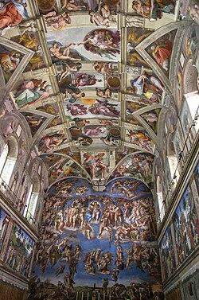

She said I stare more at ceilings,
Than I stare at her,
How do I tell her,
For people like me,
A ceiling is the canvas,
for the chaos,
of an empty mind,

They come alive and die,
with every thought that,
decides to first exist, and then
to fade away,
A peek within is what you get,
then in your own depths, they hide,

Everywhere, everytime,
there's one above,
for the rich, it comes
with chandeliers,
for the poor,
it is the entire sky,

you see, I think ceilings are the Goddess's eyes,
showing you what you want,
and to her, what lies inside,
I wonder if that is why,
Michelangelo didn't leave Sistine's ceilings white,
for he didn't want the gods to see,
what men had in their minds,

I stare at ceilings to see through myself, and to let myself bare,
and I let you see me as I do so,

I think your eyes are prettier.

